**A True Story**

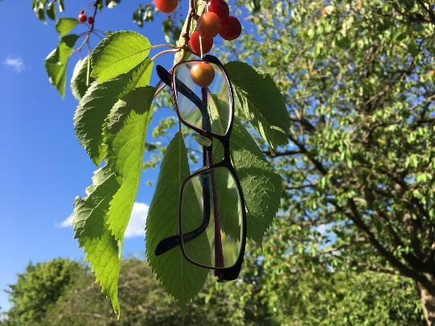

***Spectacles in a Cherry Tree***

The walk way to the Cemetery in Selly Park was an avenue of fragrant flowering blossoms all through Spring and early Summer. A delightful compensation for all of us behind closed gates for over three months now. The cherry trees in particular bore fruit in abundance.  
  
One evening as a Sister was taking a stroll in the garden and, like many others, she plucked some cherries from a tree. She came back in to discover that her reading glasses were missing. The search, narrow at first to her immediate surroundings, soon broadened out to retrace every step and every possible location visited. Sisters were enlisted to help in the search. There were even surreptitious glances in the direction of any Sister spotted wearing similar glasses.

One day passed, two days passed and on the evening of the third day another Sister was taking a stroll in the garden. She decided to pluck a cherry from the overflowing tree and lo and behold there before her ever vigilant eyes were the errant spectacles perched precariously on a rather frail branch. She immediately summoned the presumed owner and never one to miss a photo opportunity took some amazing pictures of this rather unusual sight.

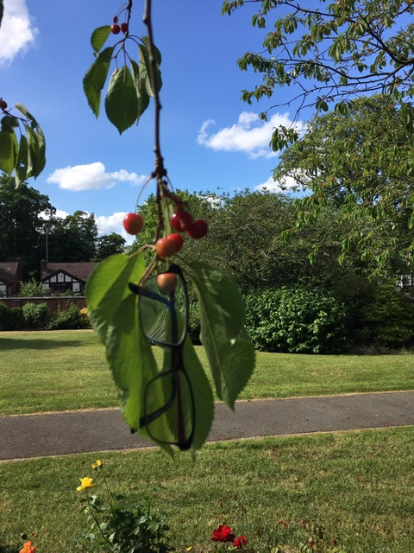The Sister now gratefully re-united with her glasses could only conclude that they slipped from her hand as she plucked the cherry! The glasses had weathered wind and rain over two nights and had not stirred. The moral of this true story is not to take your reading glasses with you when you pick fruit!

