The Lord works in wonderful ways, He always guides
our steps to meet His most needy and beloved children

This came true for me when I met some homeless people on my way to work after a night of snow. Some people were trying to warm themselves on some hot water pipes. They were very surprised when I stopped and spoke to them about their situation. From that moment, I prayed and realised that I had to do something about it, but how could I help these homeless people. As a community we discussed the situation.
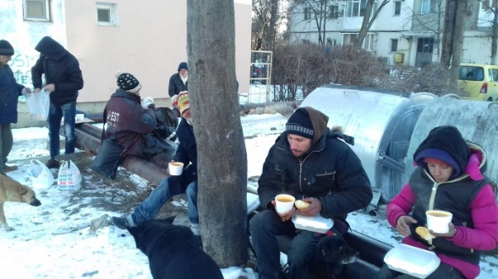
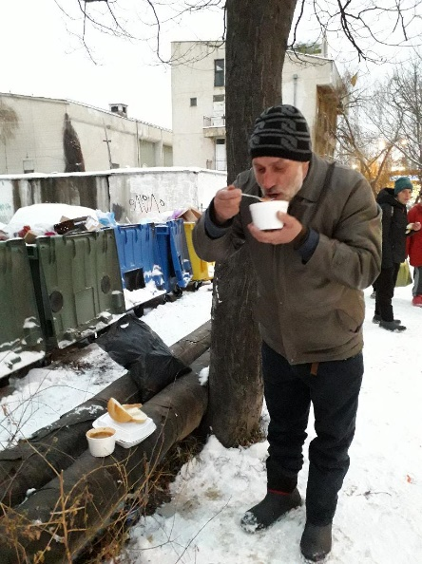
We received some money from abroad to be used to help the poor and we went to a nearby restaurant and luckily met a lady who understood and gave us a very reasonable price so that we could provide hot food for our new friends. The meal consisted of soup, bread, meat and vegetable, all wrapped up nicely in individual containers. We began on 11.01. 2017 with 5 homeless people which quickly grew to 43. You can imagine the difference this hot food makes especially when the winter temperature can reach -28° C. Each weekday one of us distributes the food to those who come, most on a daily basis. Obviously the summer months bring some relief to these street people. When possible they do some small jobs, such as carrying vegetables and tidying up for the stall holders at the local market and in return receive some food.
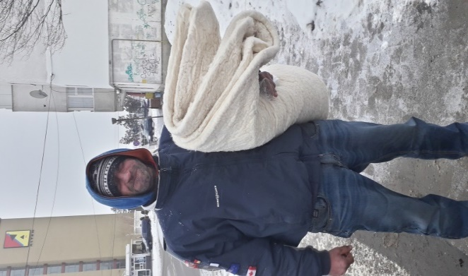
Unfortunately this category of people often have health problems due to many years on the streets in all weathers. Some have mental problems or are alchol dependant. Sometimes we help them with medication or the sever cases who need to be rushed to hospital.
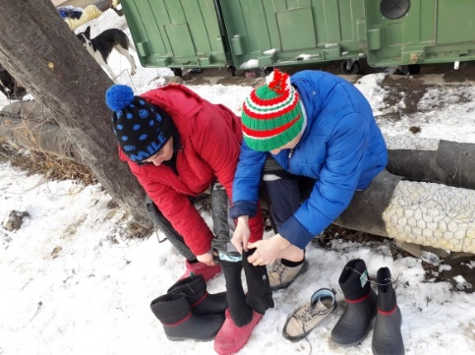
The local council decided to cover up the pipes as they were carrying out some repairs so the homeless have lost a source of heat. Luckily with the help of many generous people we were able to buy some warm boots, socks, thick blankets, jackets and other clothes for them before Christmas. They are always very happy and grateful to recieve such useful gifts. Some volunteers help the sisters to distribute the food and items of clothing.
Last November the restaurant closed and fortunately we were able to find another one that agreed to sell us good wholesome food at a decent price.
We were also fortunate when 2 priests and 3 seminarians from the Don Guanella Community volunteered to help us carry and distribute the food to the homeless people.
With the help of lots of wonderful generous people we are able to continue doing this work for the glory of God and for the good of so many poor people.
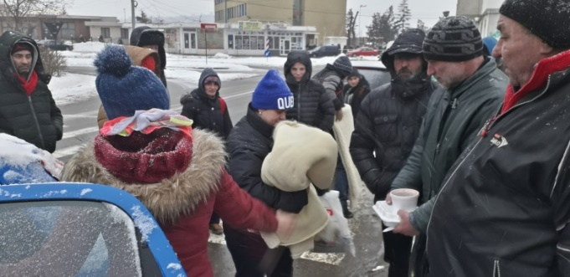
I know there are many needs all around us, we are not able to meet them all, but I know and I trust that together and with the Lord’s help we can reach some of them and make a huge difference in their lives.
We thank the Lord each day for the privilage of working in his harvest and we appreciate the generousity of people of good will who have been willing all these years to support us in this work.

May the Lord bless each one of us and may He give us wisdom and joy!

Sr. Simona.

