First Profession at St. Paul’s Convent, Selly Park, Birmingham
24 February 2024

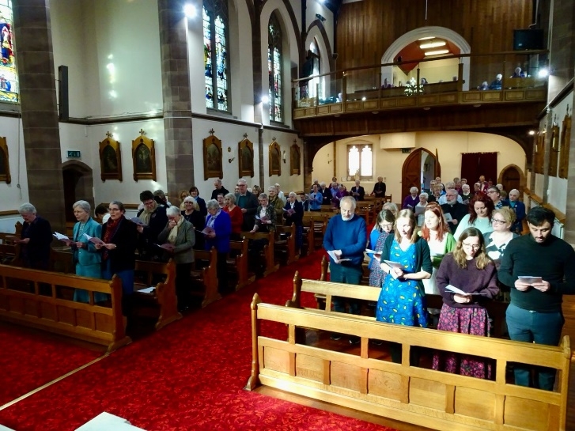
A Ceremony of Religious Profession, is a rare event, nowadays, at least in Apostolic Religious Congregations in the Western World. So, in a spirit of joyful celebration, family, friends and Sisters gathered on 24 February to witness Lieve Goris make her First Religious Profession in the Congregation of the Sisters of Charity of St. Paul, the Apostle, at the Motherhouse in Selly Park, Birmingham.

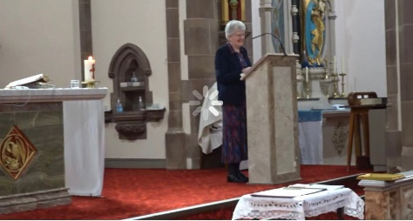
At the beginning of Mass, Sister Ann Sullivan, Congregational Leader, warmly welcomed all the guests, especially members of Lieve’s family and friends from Belgium and Norway. Sr. Ann also welcomed members of the L’Arche community from Manchester, where Lieve was a member before entering the Congregation in Selly Park and volunteers from St. Chad’s Sanctuary, Birmingham where Lieve did voluntary work as part of her apostolic experience. Sr. Ann welcomed Fr. Christopher Handforth, Convent Chaplain, and Chief Celebrant of the Mass, along with three other con-celebrants. Finally, Sr. Ann welcomed the Sisters present and those following on the live stream.
In her welcome address, Sr. Ann spoke of Lieve’s generosity in responding wholeheartedly to God’s call to Religious Life and assured her of the support of all the Sisters in the Congregation as she embarked on the next phase of her Religious Life. She reminded all of us of the importance of witnessing to our Christian calling.
The Profession ceremony itself followed the formula that is set out in the Constitutions of the Congregation “Our Life in Christ”. This took place after an inspiring homily preached by Fr. Handforth, in which he reminded us that “TODAY IS TODAY”, the only day we have and to live it to the fullest.
As a requirement for Profession, Sr. Ann Sullivan questioned Lieve about her request to make her profession and if she was doing so of her own free will. Lieve’s response was firm and decisive, indicating that she was fully aware of what she was undertaking and was prepared to give of her best with the help of God and the support of the Sisters. All the Sisters present confirmed their willingness to support Sr. Lieve on her onward journey.
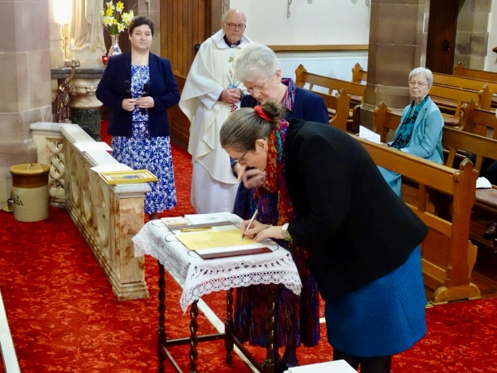
Once the documents were signed, a copy of the Constitutions and the Congregational Emblem presented to Lieve, all joined in a joyful round of applause for the newly professed Sister of St. Paul, Sister Lieve.
Mass continued, greatly enhanced by beautiful singing and music by the Sisters. At the end of a very meaningful ceremony, Sr. Ann, Sr. Lieve and the priests processed down the aisle to the rousing strains of the Congregational anthem, Great St. Paul, our heavenly patron. The procession, now joined by guests and Sisters, continued outside where numerous photographs of very happy people were taken in the bright spring sunshine.
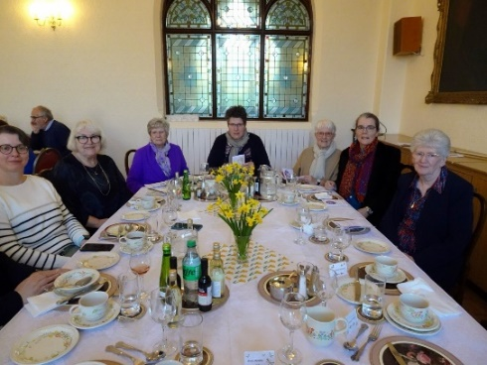
Following the photographs, all moved to the community dining room where a delicious meal was enjoyed by all. Sr. Ann thanked everybody involved in preparing for this important occasion and Sr. Lieve thanked everybody who had supported her on her journey to date.

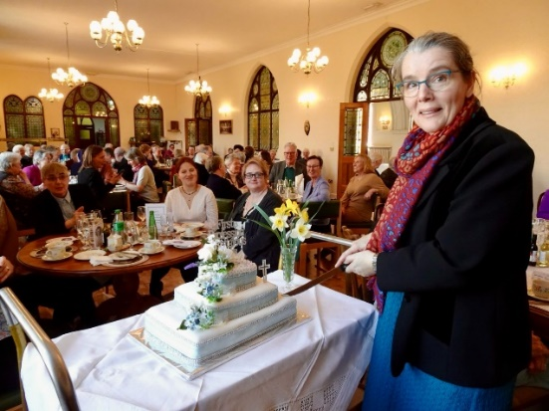
All returned later for a cup of tea and a slice of the “Profession Cake” before departing on their journeys home.
That evening, many will have prayed that we have a First Profession very soon again.

